Is the Earth still recovering from the “Little Ice Age”?
A possible cause of global warming

Syun-Ichi Akasofu

Abstract

A roughly linear global temperature increase of about 0.5°C/100 years (~1°F/100 years) seems to have occurred from about 1800, or even much earlier, to the present. This value may be compared with what the International Panel on Climate Change (IPCC) scientists consider to be the manmade greenhouse effect of 0.6 - 0.7°C/100 years. This linear warming trend is likely to be a natural change. One possible cause of the linear increase may be Earth’s continuing recovery from the Little Ice Age, a trend which should be subtracted from the temperature data during the last 100 years when estimating the manmade contribution to the present global warming trend. Thus, there is a possibility that only a fraction of the present warming trend is attributable to the greenhouse effect resulting from human activities. This conclusion is contrary to the IPCC (2007) Report (p.10), which states that “most” of the present warming is due to the manmade greenhouse effect. There is an urgent need to correctly identify natural changes and remove them from the present global warming trend, in order to accurately identify the contribution of the manmade greenhouse effect. It is pointed out that one certain way to learn about natural changes is to examine climate change before the greenhouse effect of human-produced carbon dioxide (CO₂) became significant. Further, two examples are presented to show that global climate model (GCM) results can be used to identify natural changes due to unknown causes.

Temperature Changes during the Last 3000 Years

Figure 1a shows changes of the global average temperature from 1880 to 2000 in terms of both the annual mean and the 5-year mean. The annual mean shows large excursions, indicating that the weather is always “anomalous.” The annual mean curve (or its further-smoothed version in Figure 1b) is most often used in discussing the present global warming and climate change.

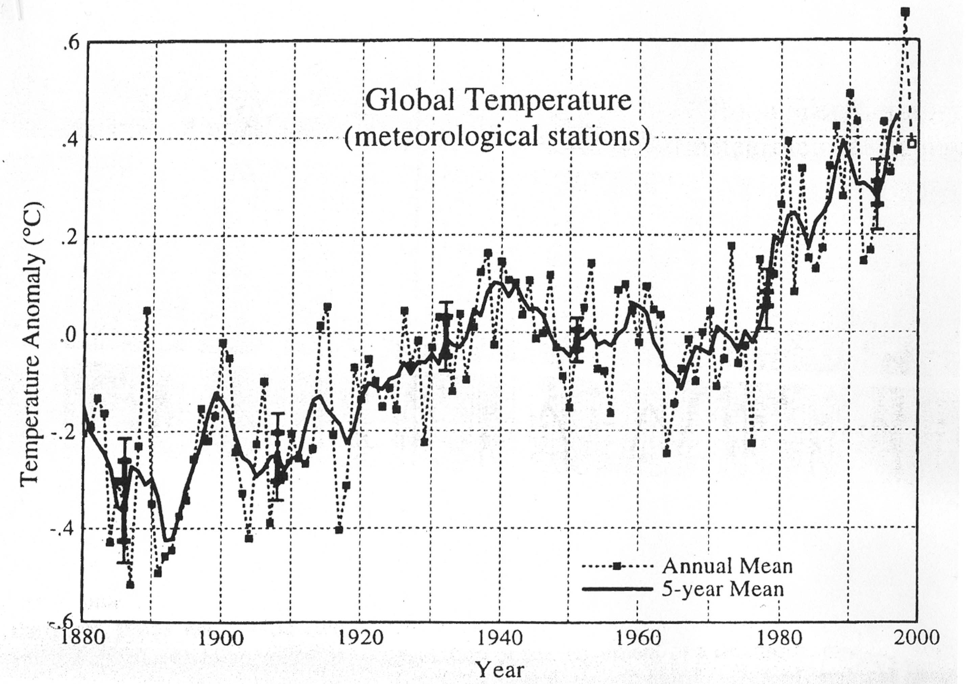

Figure 1a: The global average temperature from 1800 to 2000.

When examining Figure 1a, both professionals and nonprofessionals alike expect that temperature changes will be approximated with a straight line, and “fluctuations” superposed on it. Such a figure is shown in Figure 1b. It is important to note that the global warming issue is concerned with these slow changes in Figure 1b, not large fluctuations in the annual mean in Figure 1a. Note also that the gradient of the straight line is about 0.5°C /100 years.
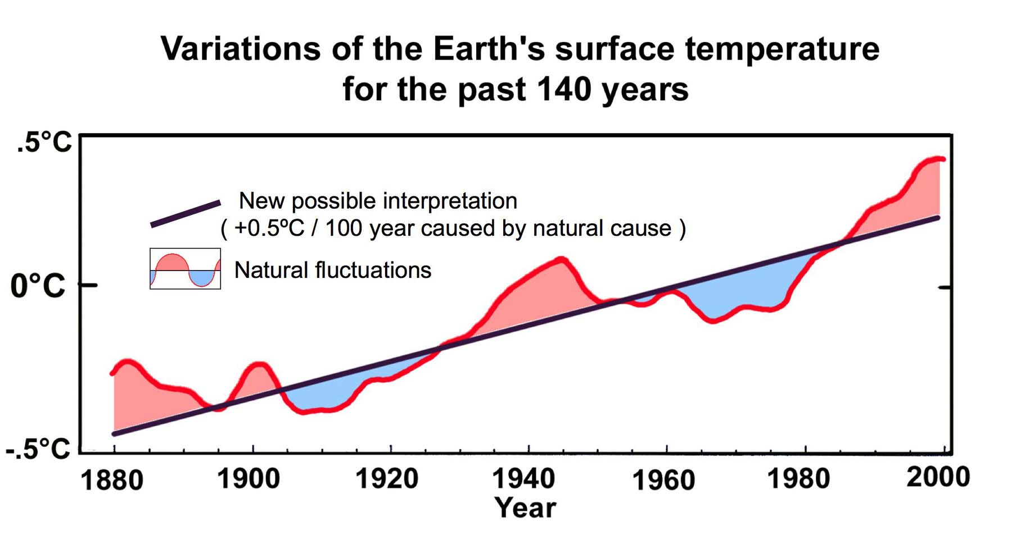
Figure 1b: An interpretation of Figure 1a showing temperature changes that consist of a straight line and fluctuations superposed on it. The red line is a smoothed version of the 5-year mean in Figure 1a.

Figure 2 shows both the global average temperature (red) and the temperature measured at stations widely distributed along the coast of the Arctic Ocean (blue) during the last 100 years or so (Polyakov et al., 2002). One can see that the magnitude of temperature change is significantly larger in the Arctic. A similar result was shown in the Arctic Climate Impact Assessment (ACIA) Report (2004); see p. 23. In particular, fluctuations are greatly “amplified” in the Arctic. There occurred two major fluctuations, one between 1920 and 1975, and one after 1975. The arctic data indicate that the two fluctuations in the global average data should not be ignored as minor fluctuations.
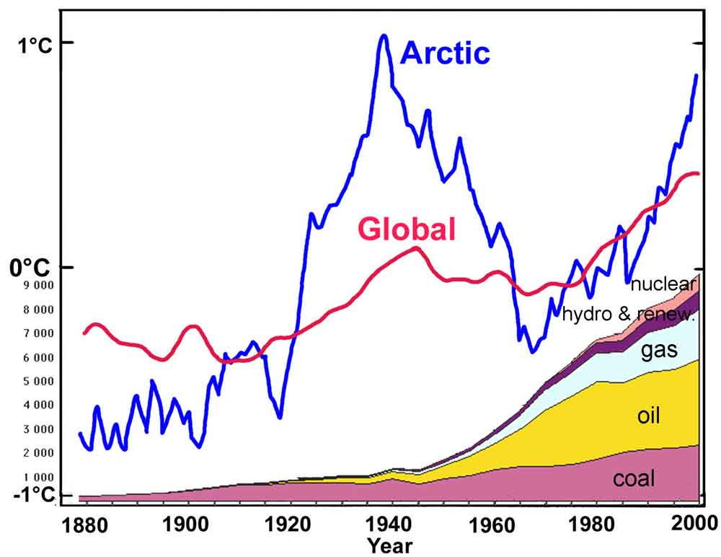

Figure 2: Temperature changes, 1880-2000. Red – global average change (IPCC Reports). Blue – data from stations along the coastline of the Arctic Ocean (Polyakov et al., 2002). The figure shows also the amount of various sources of energy used during the last century; gas, oil, and coal all release CO₂.
The figure also indicates the amounts of CO₂-producing coal, oil, and natural gas, as well as amounts of nuclear and hydro/renewable energy sources consumed during the same period. It can be seen that the temperature increased from 1910 to 1945 and then decreased from 1945 to 1975; the latter period coincided with the period of a rapid increase in fossil energy consumption. The cause of this temperature increase and decrease is not well understood. Some scientists (and news media) declared, at the time of the decrease from 1945 to 1975, that a new Big Ice Age was coming and that we should urgently prepare for it, with rhetoric that sounds very similar to that used about the present global warming. The temperature began to increase again starting in about 1975.

As can be seen in Figure 2, the relationship between the air temperature and the amount of CO₂ in the air is not obvious at all. It is crucial to investigate the nature of the temperature rise between 1920-1940 and the rise after 1975. As Figure 2 shows, CO₂ in the atmosphere began to increase rapidly after 1940, while the temperature decreased from 1940 to 1975. Thus, the large fluctuation between 1920 and 1975 can be considered to be a natural change, until proven otherwise. Therefore, unless the difference between the two changes can be understood, it is not possible to say with confidence that the rise after 1975 is mostly caused by the greenhouse effect. It is perfectly reasonable to suspect that the rise after 1975 contains a significant natural component.

Figure 3 shows temperature changes from 1725 to 2000, which were deduced from ice cores at Severnaya Zemlya, an island in the Arctic Ocean (Fritzche et al., 2006). This figure extends the data in Figure 1a to earlier periods, from 1880 back to 1725, so that the straight line in Figure 1b can be extended to 1775 or so. Figure 3 also includes a thermometer record from Vardo in Northern Norway. The bottom curve is the same as the “Arctic” in Figure 2. The credibility of the ice core record is supported by the similarity between the Norwegian temperature record and the arctic data by Polyakov et al. (2002), or vice versa.
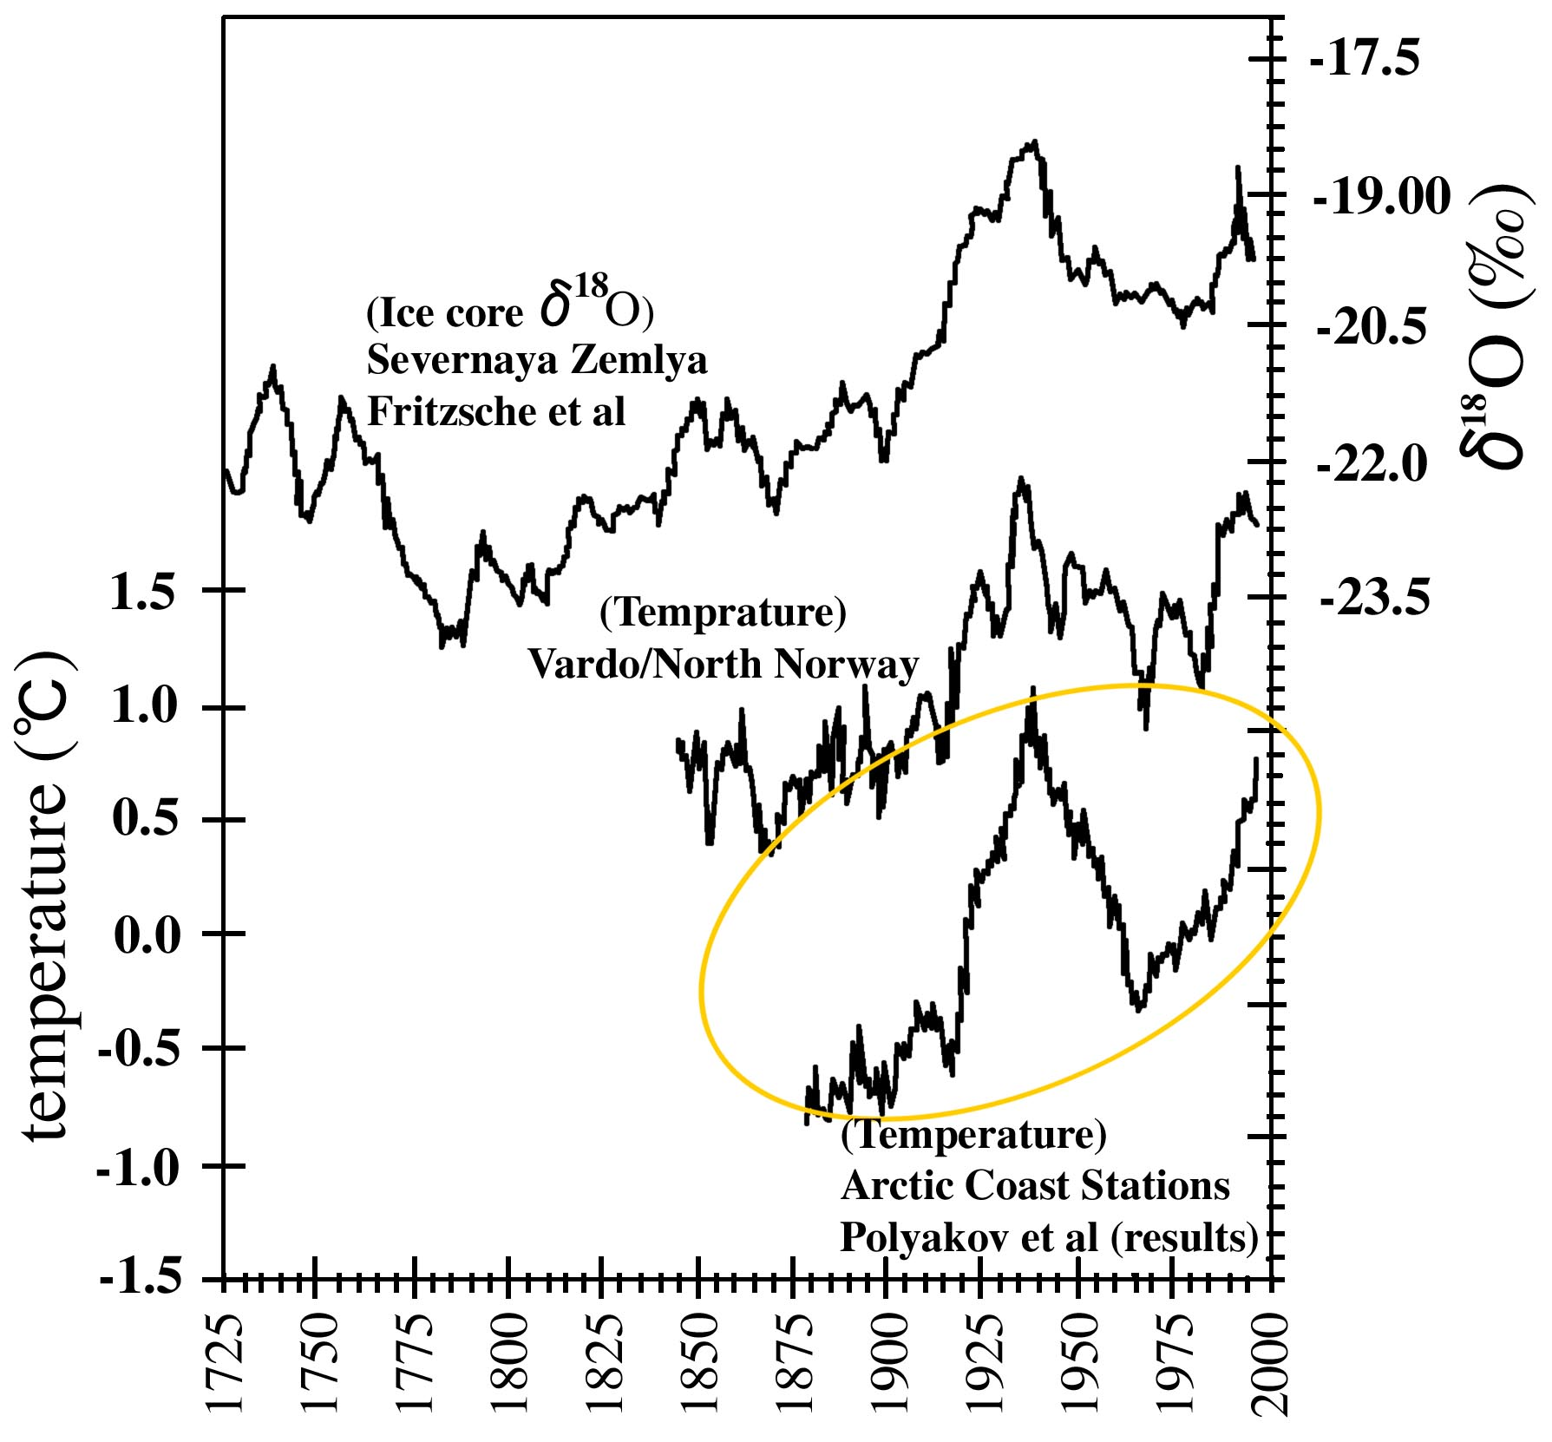

Figure 3: Late Halocene ice core record from Akademii Nauk Ice Cap, Severnaya Zemlya, Russian Arctic, together with temperature records from Vardo, Norway, and from stations along the arctic coast (Polyakov et al., 2002); the latter is the same as the blue curve in Figure 2 (Fritzsche et al., 2006).

Figure 4 shows temperature changes from about 1000 BC to about 2000 AD, covering a 3000-year period. The temperature was deduced from cores obtained from deposits in the Atlantic Ocean (Keiwin, 1996). The 3000-year average is also shown as a reference line. It can be seen that there occurred a minimum temperature period that is called the “Little Ice Age,” which began in 1200 or 1400 (depending on where the baseline is drawn). There occurred also a broad warm period centered around 1000, which is called the “Medieval Climate Optimum” or the “Medieval Warm Period.”
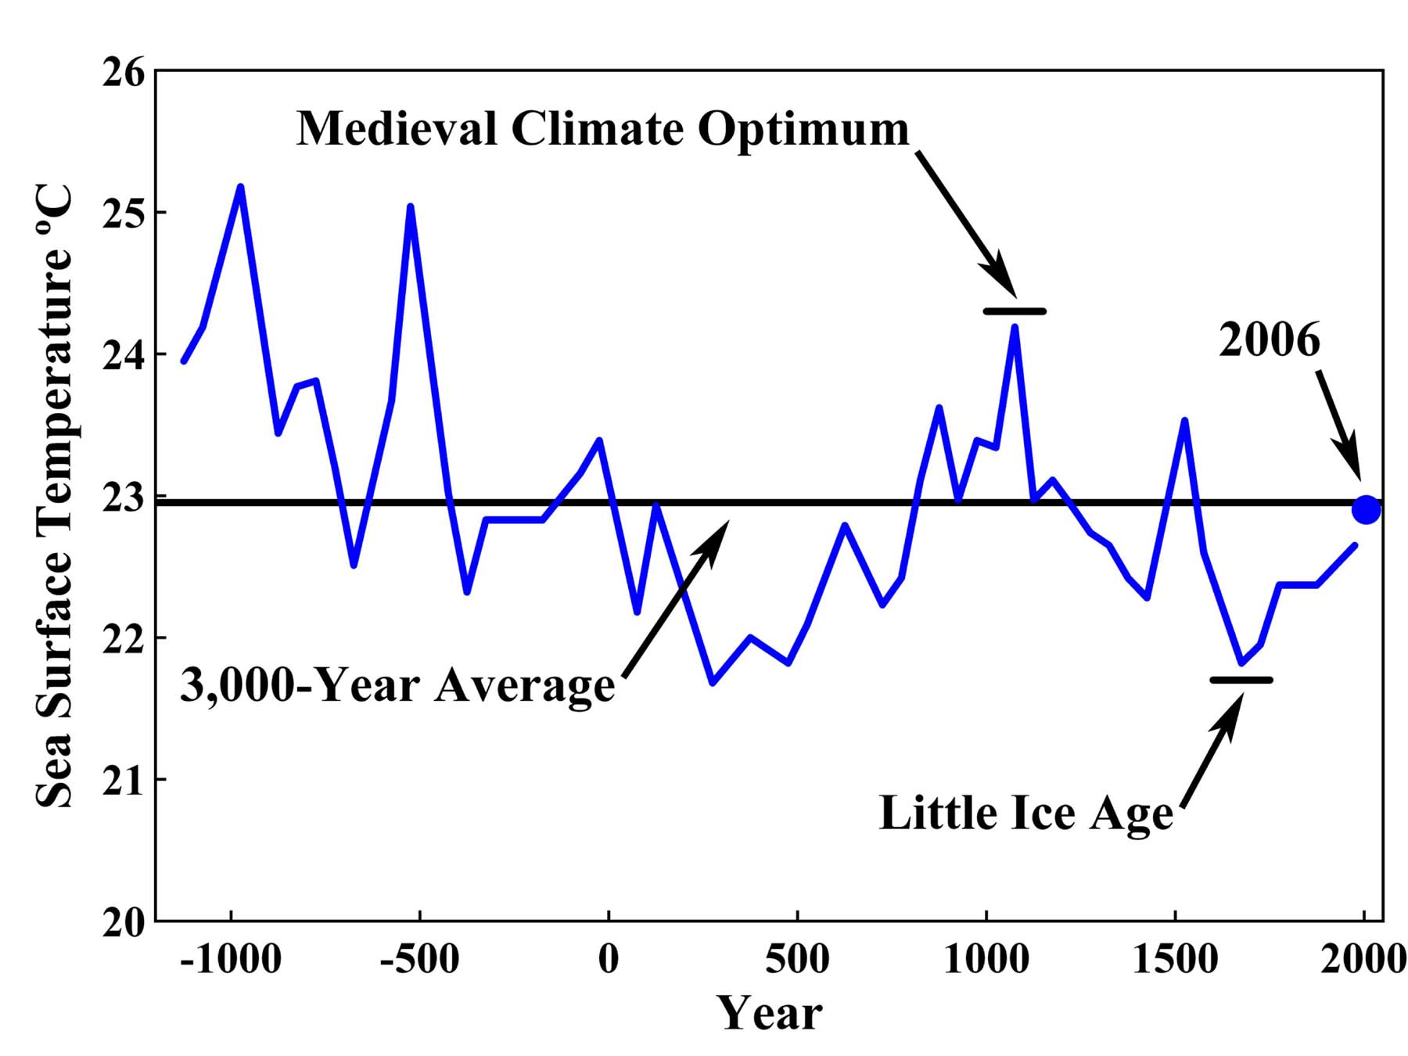
Figure 4: Temperature changes from about 1000 BC to about 2000 AD, about 3000 years of data, deduced from cores obtained from deposits in the Atlantic Ocean. The 3000-year average is also shown as a reference line. The figure was originally produced by Keigwin (1996); this is a modified version of it by Robinson et al. (2007).

Figure 5a shows the ice core temperature at the GISP-2 site in Greenland (Allen, 2000). At the very least, one can recognize that the Earth experienced the Little Ice Age during the last few hundred years from 1200 to 1800 and the Medieval Warm Period from 800 to 1200. Figure 5b is similar to Figure 5a, but extends the data back 10,000 years. There were large fluctuations of temperature in the past, which are obviously natural changes. It is quite likely, as Figures 4, 5a, and 5b, as well as Figure 1a indicate, that the Earth is recovering from the Little Ice Age and experiencing a new post-Little Ice Age warming trend.

At this point, we encounter one of the fundamental problems in both climatology and meteorology. Is there any definitive evidence to conclude that the Little Ice Age ended by 1900, as many claim? Permafrost that formed during the Little Ice Age still exists around Fairbanks, although it is thawing (Romanovsky, 2006). More fundamentally, how can we determine the “normal” or “standard” temperature from which deviations (warming or cooling) can be considered to be abnormal? In Figure 4, the reference line is arbitrarily chosen as the average value during the 3000-year period. At the present time, there is no reference level that allows us to conclude that the Little Ice Age was over by about 1900. The problem is that what is “normal” and “standard” depends on the chosen period and the length of the period.

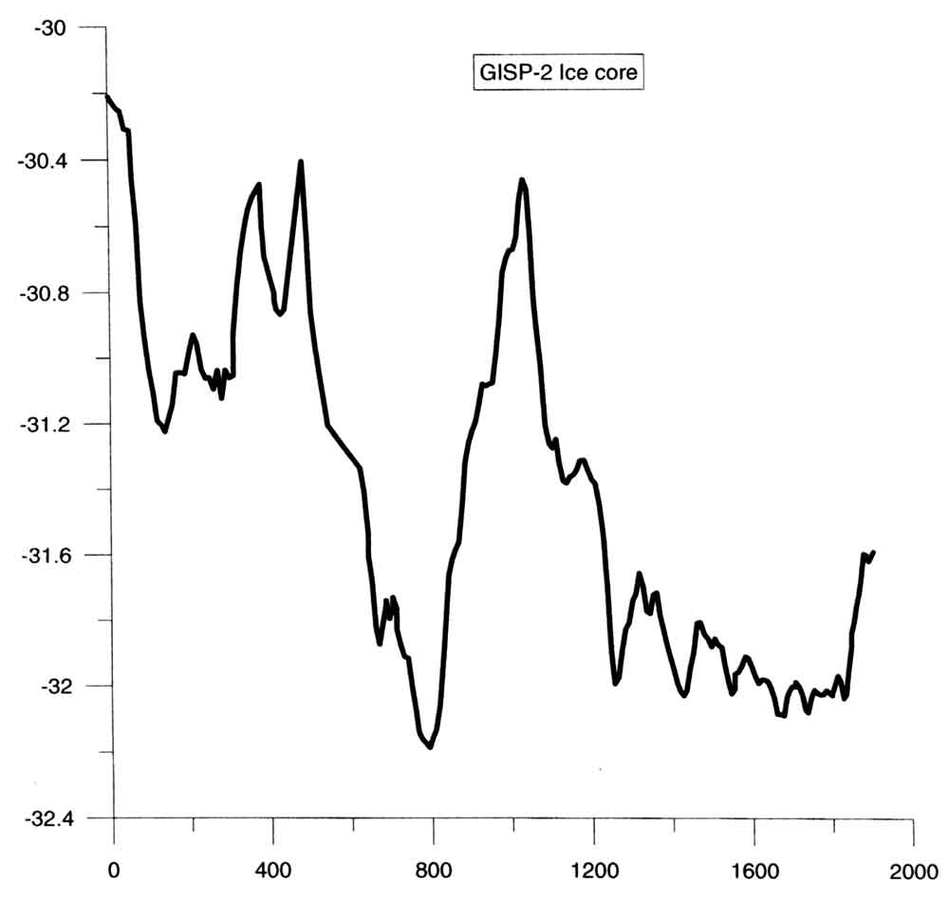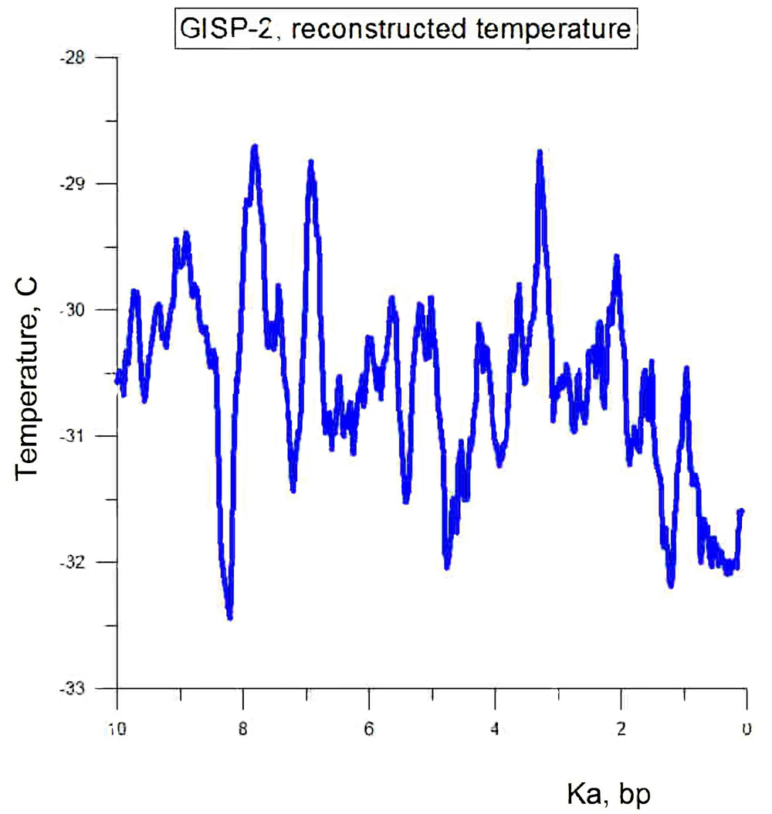

Figure 5a (left) and 5b (right): Ice core temperature at the GISP-2 site in Greenland (R.B. Alley, 2000), extending two thousand years (Ka) before present (bp) and 10 Ka bp, respectively.

There are three important points to make about Figures 3, 4, 5a, and 5b.

(1) The straight line in Figures 1b and 2 can be extended to 1700 or earlier.
(2) There is nothing unusual or anomalous about the present warming trend.
(3) There were periods in the past that were much warmer than the last century, including around 100 BC, 500 BC, and many times earlier.

Although it is not shown here, there were also much longer and warmer periods soon after the Earth recovered from the Big Ice Age, about 12,000 years ago (cf. Wilson et al., 2000).

Climate change during the last 100 years or so has been intensely discussed over the last few decades in terms of the manmade greenhouse effect of CO₂. However, it is unfortunate that the present global warming is focusing only on the temperature changes during the last 100 years or even only after 1975.

The IPCC Reports in the past state that the global average temperature increased about 0.6°C - 0.7°C (~1°F) during the last 100 years and that “most” of the increase is caused by the greenhouse effect of manmade CO₂. However, there is so far no definitive proof that “most” of the present warming is due to a manmade greenhouse effect.

It is well known that CO₂ causes the greenhouse effect, so it is natural to hypothesize that CO₂ is one of the causes of the present warming trend. However, it is not appropriate to conclude that the 0.6°C - 0.7°C rise is mostly due to human causes without carefully examining the contributions of natural changes. This point is missing in the present debate on global warming.

It is natural to assume by glancing at Figure 1a that there was, as a first approximation, an almost linear increase in the natural temperature of 0.5°C/100 years. It is somewhat surprising that there has, so far, been no debate on this and many other interpretations of Figure 1a. Although the IPCC claims that the hypothesis of the manmade greenhouse effect is proven by GCM results, one can test the hypothesis only qualitatively, not quantitatively, at this stage in the development of modeling and simulation, because there are a large number of parameters that can be adjusted or “tuned” to reproduce the 0.6°C - 0.7°C rise. In this case, the possibility is high that a supercomputer generates a “right” answer for wrong reasons. This point will be discussed later.

The main purpose of this article is to provide various published data in greater detail to substantiate that the Earth is in the process of recovering from the Little Ice Age.

The Little Ice Age

There are many documents that suggest that the period between 1500 and 1900 was relatively cool; the River Thames was frequently frozen in the later part of the 17th century (Lamb, 1982) and stories of the exploration of the Northwest Passage also hint that sea ice conditions in Northern Canada in the latter part of the 1800s were much worse than today; it is now possible to cruise the passage without much assistance from icebreakers. Although there is some doubt about the exact timing of the Little Ice Age, it is possible to infer that the period between 1500 and 1900 was relatively cool in many parts of the world (cf. Gribbin (ed.), 1978; Lamb, 1982; Crowley and North, 1991; Fagan, 2000; Burroughs, 2001; Serreze and Barry, 2005).

Figure 6 shows ice core data from Quelccaya, Peru, and Dunde, China, comparing them with decadal temperature departures in the Northern Hemisphere. There is little doubt that the temperature was significantly lower than the present during the period between 1600 and 1800.

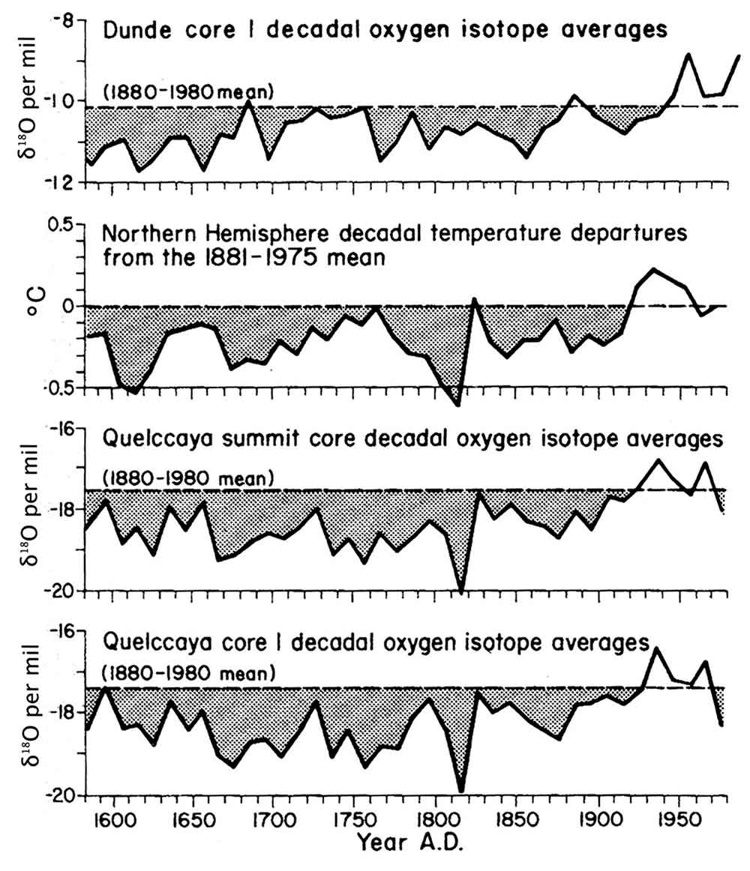

Figure 6: Decadal temperature departures (from the 1881-1975 mean) in the Northern Hemisphere from 1580 A.D. to 1975 (second) compared with decadal average δ¹⁸O values for both the Dunde, China, D-1 core (top) and Quelccaya, Peru, ice cores (third and fourth) over the same time period. For the δ¹⁸O records, the dashed line is the 1880-1980 A.D. mean (Thompson, 1992).
Figures 7, 8, 9, 10, and 11 suggest a roughly linear change of temperature from the earliest recordings by Burroughs (2001), Tarand and Nordli (2001), and van Egelen et al. (2001). The trend lines and curves were drawn by the quoted authors, not by the present author.

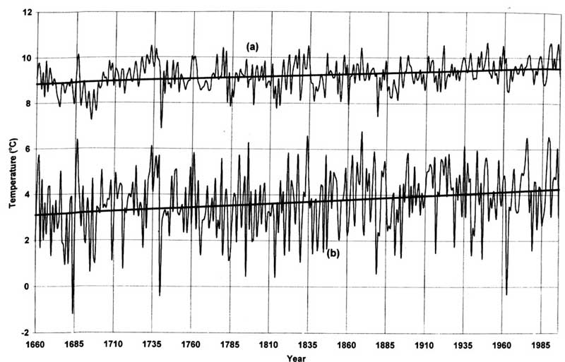

Figure 7: The linear trends for the temperature of central England over the period 1660-1996 for (a) the annual data, and (b) the winter months (December to February), show a marked warming. In both cases, this warming is significant, but although the temperature rise is greater in winter, this trend is less significant because the variance from year to year is correspondingly greater (Burroughs, 2001).
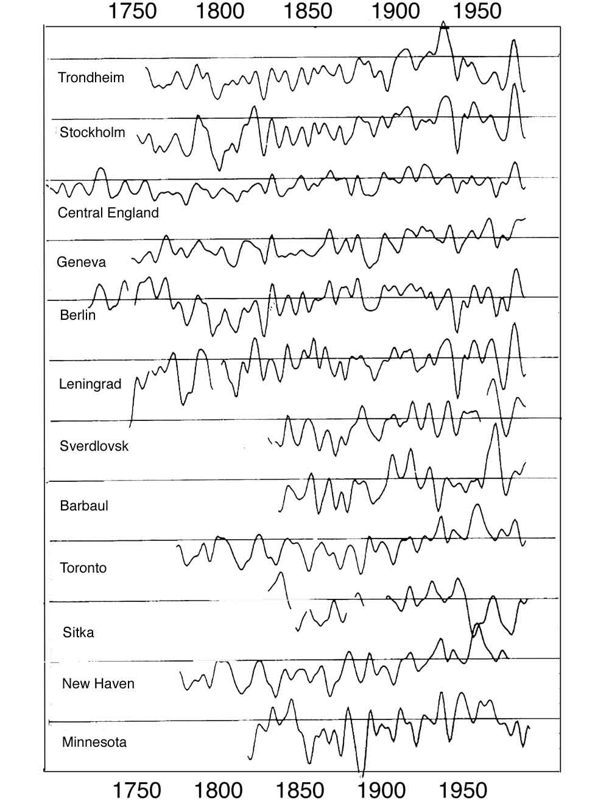

Figure 8: Temperature change at a number of stations in the world (Jones and Braley, 1992).
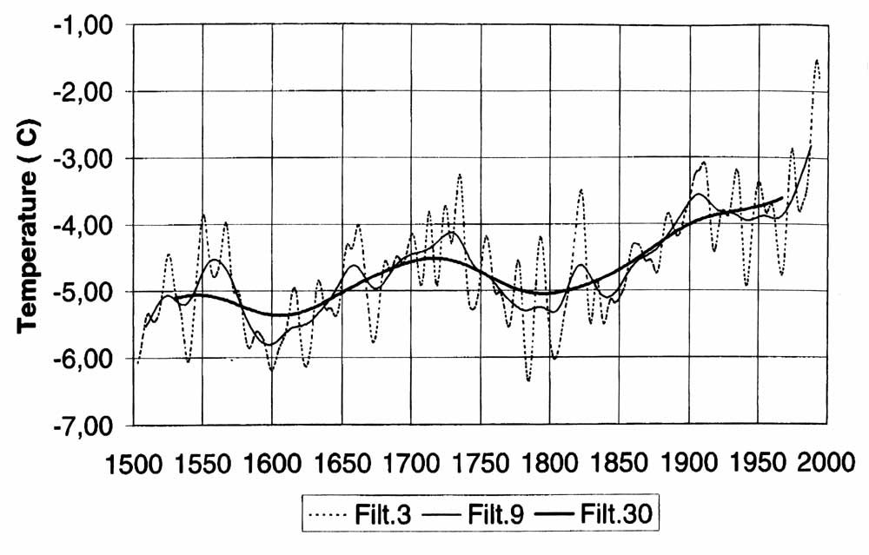
Figure 9: Winter temperature (December-March) at Tallinn since 1500, based on ice break-up dates in Tallinn port. The series is smoothed by Gaussian filters of 3, 9, and 30 years as standard deviations in the Gaussian distribution (Tarand and Nordli, 2001).

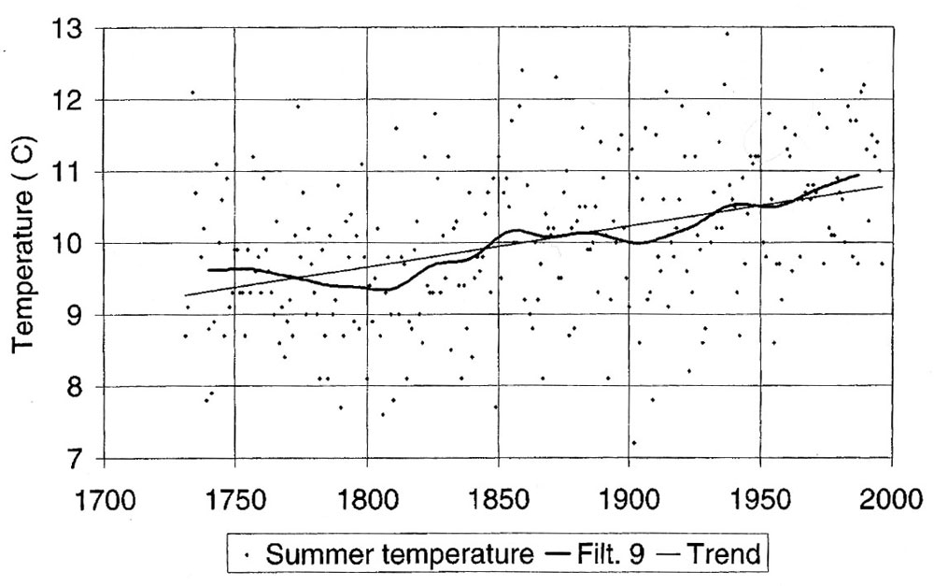

Figure 10: Summer temperature (April to July) for Tallinn, which is based on ice break-up and rye harvest data and on instrumental observations. To ease the study of variations on a timescale of approximately 30 hours, the observations are smoothed by a Gaussian filter with standard deviation of nine years in its distribution (curve). A trend line for the whole period is also shown (Tarand and Nordli, 2001).
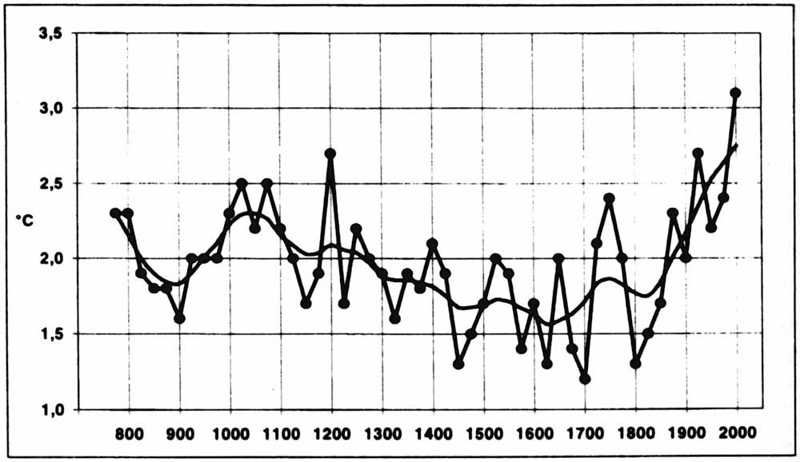

Figure 11: 25-year mean winter (DJF) temperature at De Bilt (van Engelen et al., 2001). This figure includes a longer data period than Figures 4, 5, and 6.

The fact that an almost linear change has been progressing, without a distinct change of slope, since 1800 or even earlier (possibly as early as 1660, long before the Industrial Revolution), suggests that the linear change is a natural change. As shown by Figure 2, a rapid increase of CO₂ began only after 1940.

Rebounding from the Little Ice Age

It is clear from all the figures shown earlier that the Earth has been in the process of recovering from the Little Ice Age since about 1800. There is further supporting evidence of this rebound. Figure 12 shows that the southern edge of sea ice in the Norwegian Sea has been continuously receding from about 1800 to the present. Further, there is a possibility that the present recession is related to an intense inflow of warm North Atlantic water (Figure 13); this phenomenon is known as the North Atlantic Oscillation (NAO), which is a natural phenomenon (Polyakov et al., 2002, 2007). In fact, sea ice in the Arctic Ocean is not shrinking uniformly. The largest shrinkage is taking place where the warm North Atlantic water is flowing, namely along the Siberian coast (Figure 14). It is important to note in this connection that the sea ice surrounding the Antarctic Continent has had no definite sign of major change during the last several decades. It is expected that the greenhouse effect should cause similar effects on sea ice in both hemispheres, but this is not the case. Therefore, the shrinking is a feature unique to Arctic Ocean ice. The North Atlantic flow may be one cause of this unique change.

Further, Figures 15 and 16 show examples of glaciers in Alaska and New Zealand, respectively, which have been receding from the time of the earliest records. There are a large number of similar records from the European Alps and elsewhere (Grove, 1988). Therefore, it can be assumed that many glaciers advanced during the Little Ice Age (Fagan, 2000) and have been receding since then. Thus, the retreat is not something that began only in recent years.

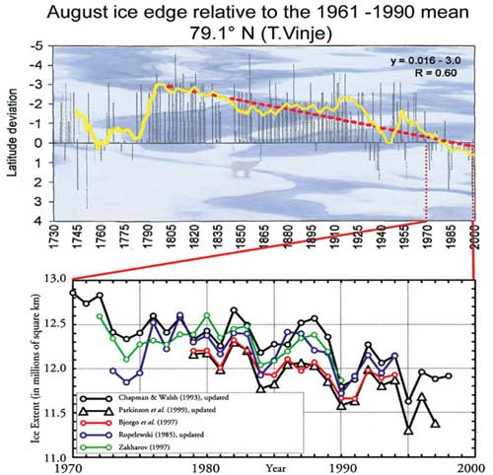

Figure 12: Upper, retreat of sea ice in the Norwegian Sea (Vinje, 2001). Lower, satellite data corresponding to the period between 1970 and 1998 are shown.

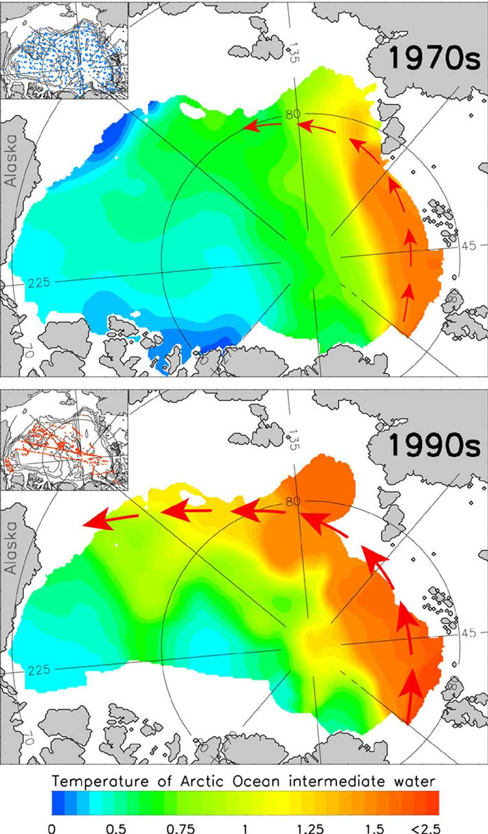
Figure 13: Inflow of warm North Atlantic water into the Arctic Ocean (Polyakov, 2006).

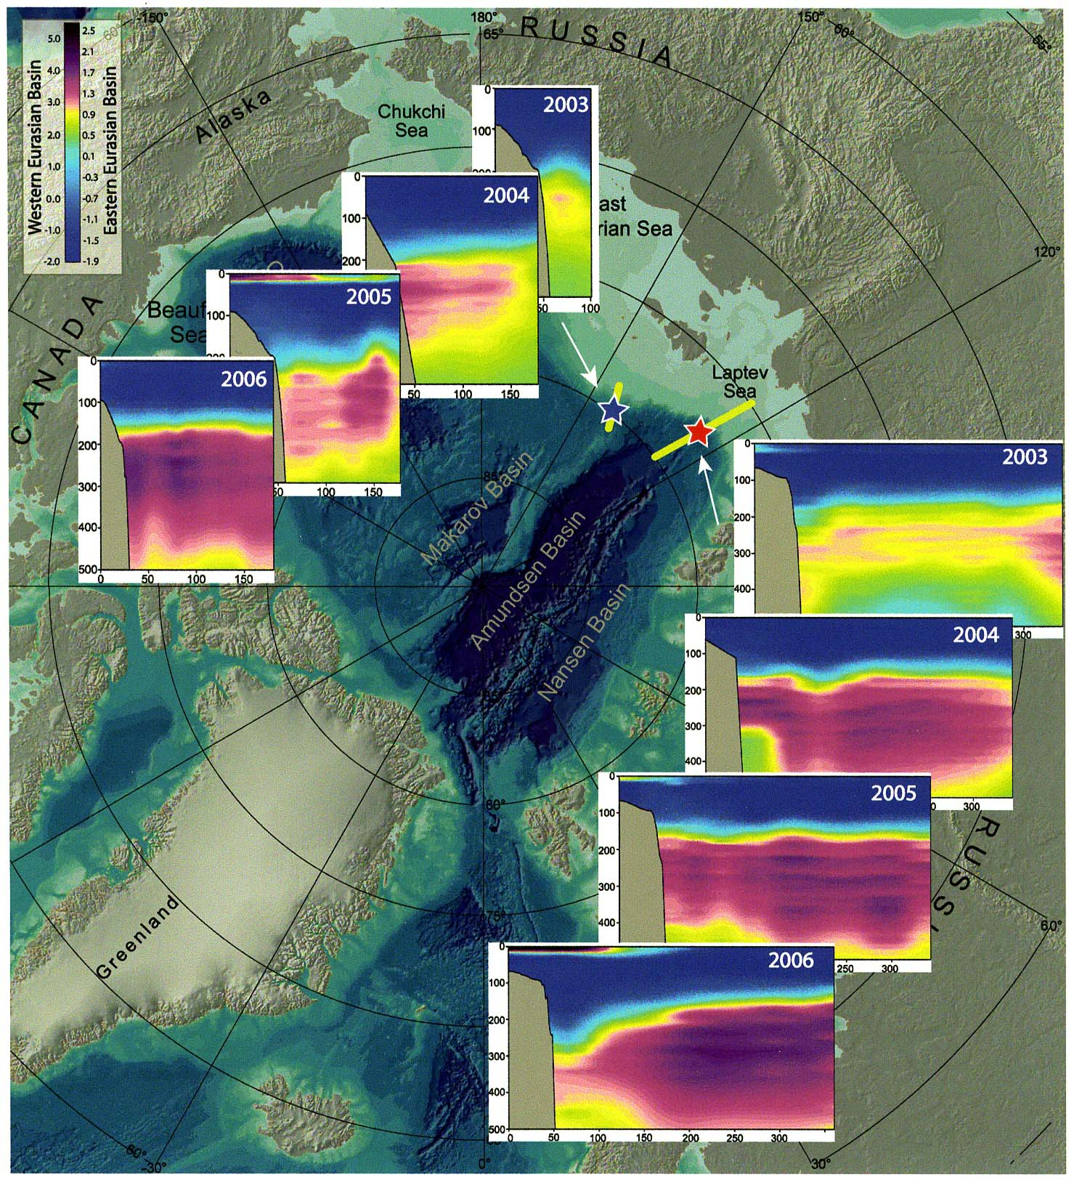
Figure 14: Changes of seawater temperature at two locations in the Arctic Ocean. The warm water from the North Atlantic Ocean is flowing deeply into the Arctic Ocean (Polyakov et al., 2007).

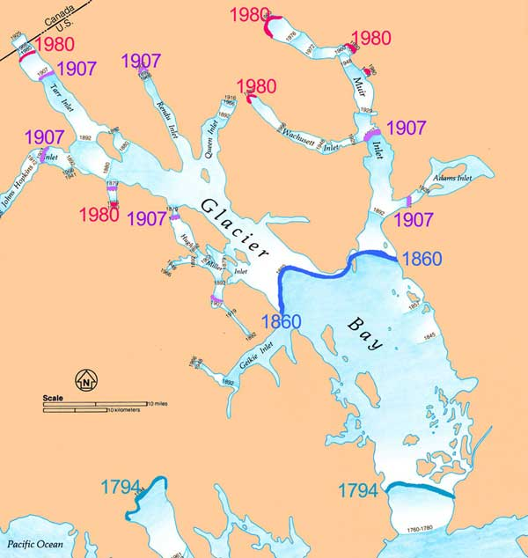

Figure 15: Retreat of glaciers in Glacier Bay, Alaska (Alaska Geographic, 1993).

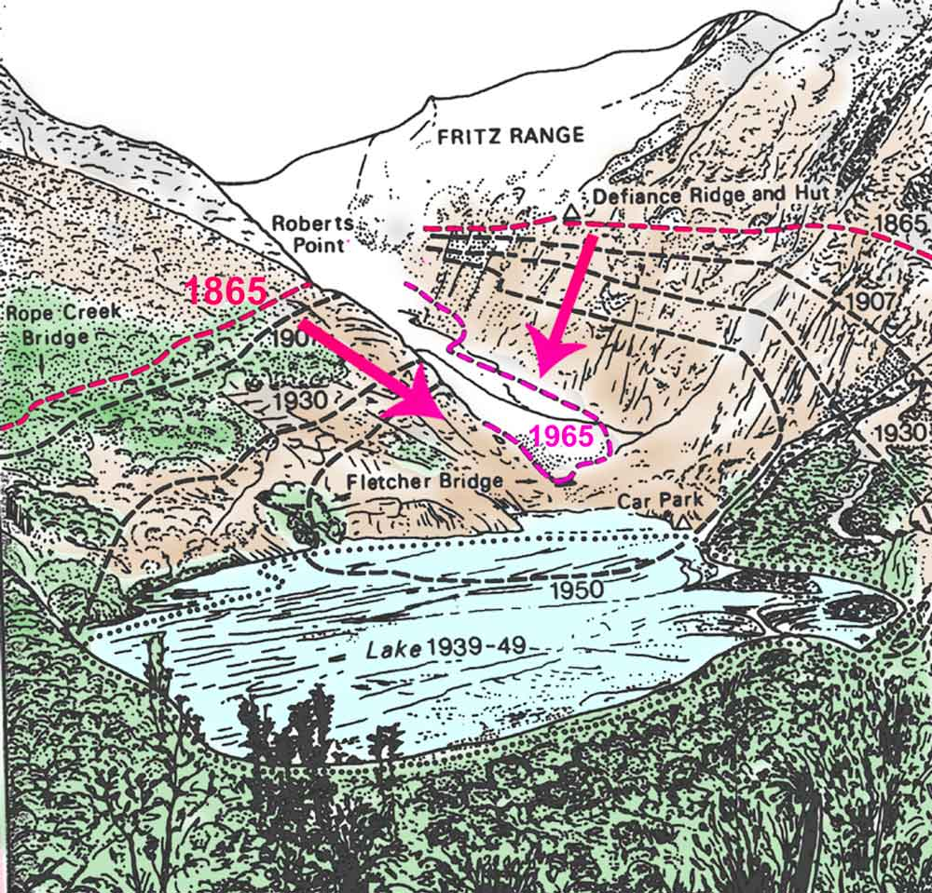

Figure 16: Retreat of the Franz Josef Glacier in New Zealand; the coloring is added by the present author for emphasis (Grove, 1988).

Gradient of the Linear Increase

As far as the gradient of the linear change is concerned, it can roughly be estimated to be about 0.5°C/100 years based on all the figures. It is very interesting to recognize that this gradient is almost comparable with the IPCC’s estimate of 0.6°C - 0.7°C/100 years. Therefore, the linear change, which is likely to be a natural change, should be subtracted from the observed increase in order to identify and estimate the manmade greenhouse effect, namely (0.6°C - 0.7°C/100 years) - (0.5°C/100 years) = 0.1° ~ 0.2°C/100 years. Since the maximum decrease of temperature during the Little Ice Age is estimated to be about 0.5°C (Wilson et al., 2000) to 1.5°C (Crowley and North, 1991; Grove, 2005), it is worthwhile to speculate that the Earth is still recovering. Another possibility is that the Earth is experiencing a new warming trend of unknown causes. One possible cause is the increasing solar output (cf. Soon, 2005; Scafetta and West, 2006), which I do not investigate in this note.

However, it is not my purpose here to attempt an accurate estimate of the gradient of the linear change or explore causes of natural changes. Such an estimate is beyond the scope of this note, and it is a task for climatologists. There is great uncertainty in obtaining early data corresponding to the accuracy of Figure 1a. Here, I emphasize only that a significant part of the 0.6°C - 0.7°C increase during the last 100 years includes natural changes, contrary to the statement by the IPCC Report (2007), so that natural changes must be subtracted before estimating manmade effects.

Further, the IPCC Report (2007) states that the present high temperature is “unusual” except for about 130,000 years ago (p. 10). However, if we examine the temperatures during all the other interglacial periods (240,000, 330,000, 400,000 years ago) and Figures 4, 5a, and 5b, there were periods of time that were warmer than the present one. Actually, it could be said that the present interglacial period was an abnormally cool one, and there is nothing unusual or abnormal about the present warming trend and the temperature. It seems that there were some unjustifiable efforts on the part of IPCC to stress that the present warming is very unusual.

How Linear is the Linear Change?

It is reasonable to expect that the linear change is only a rough first approximation. An accurate examination is expected to show deviations from the linear trend if the greenhouse effect is significant, namely an upward deviation from the linear change after 1940. As mentioned earlier, this is a task for climatologists.

In this respect, it is interesting to note a recent study of sea level changes (Holgate, 2007) shown in Figure 17. Although the data cover only the period after 1907, this coverage is sufficient to examine these data for an indication of accelerated sea level increase after 1940. The sea level change should reflect the expected rise associated with the thermal expansion of seawater and glacier melting during the last half century that were warned of in the IPCC Reports. Figure 17 shows that there is no clear indication of an accelerated increase of sea level after 1945, even if some individual glaciers in the world are receding at an accelerated pace. In fact, comparing the slope between 1907-1960 and 1960-2000, there is even a slightly smaller increase in the latter period. During the period of his study, Holgate (2007) noted that the rate of sea level rise was about 1.7 mm/year, not tens of meters as suggested in some earlier reports.

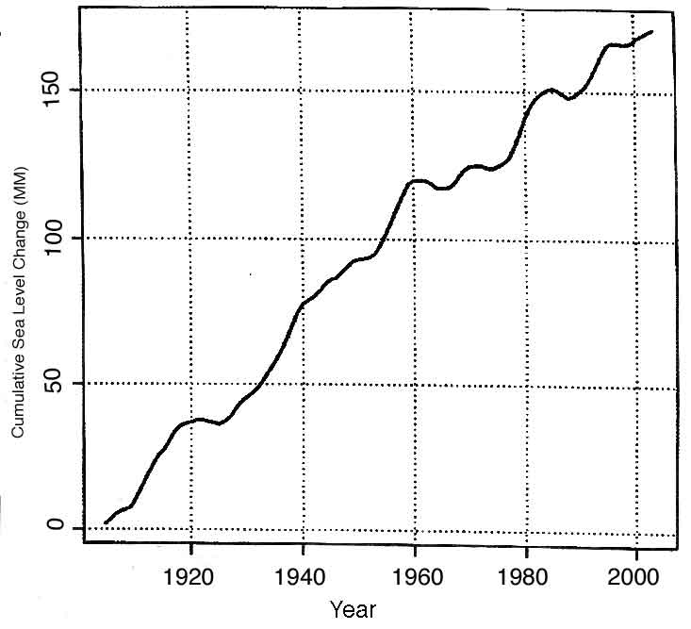

Figure 17: The mean sea level record from nine tide gauges over the period 1904-2003 based on the decadal trend values for 1907-1999. The sea level curve here is the integral of the rates (Holgate, 2007).

Fluctuations

As shown in Figures 1a and 1b, two prominent fluctuations occurred during the last 100 years. The first was a temperature rise from 1920 to 1940 and the subsequent decrease from 1940 to about 1975. The second is the present rise after 1975. As stated earlier, it is crucial to examine whether both rises are due to the same, similar, or entirely different causes. Until some study can provide convincing results on this particular problem, we should not claim that the rise after 1975 is mostly due to the greenhouse effect as did the IPCC Report.

It is interesting to note from the original paper by Jones (1988, 1994) that the first temperature change from 1920 to 1975 occurred only in the Northern Hemisphere, at high latitudes above 50° (Serreze and Francis, 2006). The present rise after 1975 is also confined to the Northern Hemisphere, and is not very apparent in the Southern Hemisphere; there may be a problem due to the lack of stations in the Southern Hemisphere, but the Antarctic shows a cooling trend during the 1986-2005 period.

Thus, it is not accurate to claim that the two changes are a truly global phenomenon, even if averaging the data from both hemispheres provided Figure 1a. The greenhouse effect is supposed to be global; the two prominent changes (1920-40 and after 1975) may be considered to be regional changes. Thus, there is a possibility that both increases are natural changes, unless it can be shown definitely that such regional changes are caused by the greenhouse effect.

It is important to note that the present global warming after 1975 is not uniform over the Earth. Although a single number, namely +0.6°C ~ 0.7°C/100 years, is used in discussing global warming, the geographic distribution of “warming” is quite complex. The upper part of Figure 18 shows the “warming” pattern during the last half of the last century, from about 1950 to about 2000 (Hansen et al., 2005). One can see that the most prominent change occurred in Siberia, Alaska, and Canada, namely in the continental Arctic. In the continental Arctic, the warming rate was several times more than the global average of 0.6°C/100 years. There is no doubt that such a prominent change contributed to the global average change in Figure 1a. It may also be noted that cooling was in progress in Greenland over the same time period.

It is of great interest to ask if GCMs can reproduce this geographic distribution of the observed changes shown in the upper part of Figure 18, since they claim to be able to reproduce the 0.6°C - 0.7°C/100 years rise. Thus, we asked the IPCC arctic group (consisting of 14 sub-groups headed by V. Kattsov) to “hindcast” geographic distribution of the temperature change during the last half of the last century. To “hindcast” means to ask whether a model can produce results that match the known observations of the past; if a model can do this at least qualitatively, we can be much more confident that it is reliable for predicting future conditions. Their results are compiled by Bill Chapman, of the University of Illinois, and are shown in the right side of Figure 19. The left side of the figure is taken from the ACIA Report (2004), which shows a trend similar to that shown in the upper part of Figure 18, namely the prominent warming in the continental Arctic and cooling in Greenland. This comparison was undertaken in an attempt to reduce differences between the observations and modeling results, because they are expected to be similar, but imperfect.

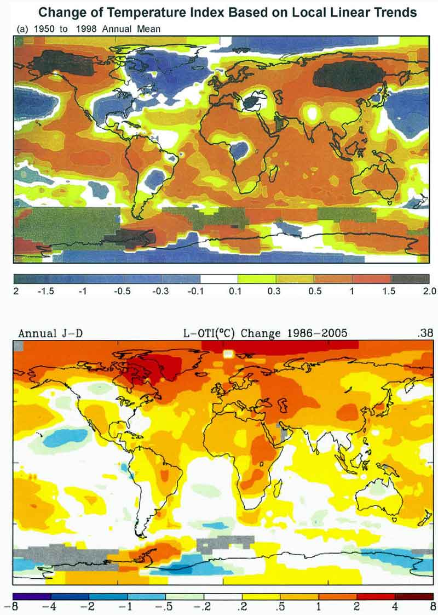

Figure 18: Upper – the geographic distribution of temperature change between 1950 and 1998 (Hansen et al., 2005). Lower – the geographic distribution of temperature change between 1986 and 2005 (Hansen, 2006).

We were surprised at the difference between the two diagrams in Figure 19. If both were reasonably accurate, they should look alike. Ideally, the pattern of change modeled by the GCMs should be identical or very similar to the pattern seen in the measured data. We assumed that the present GCMs would reproduce the observed pattern with at least reasonable fidelity. However, we found that there was no resemblance at all, even qualitatively.

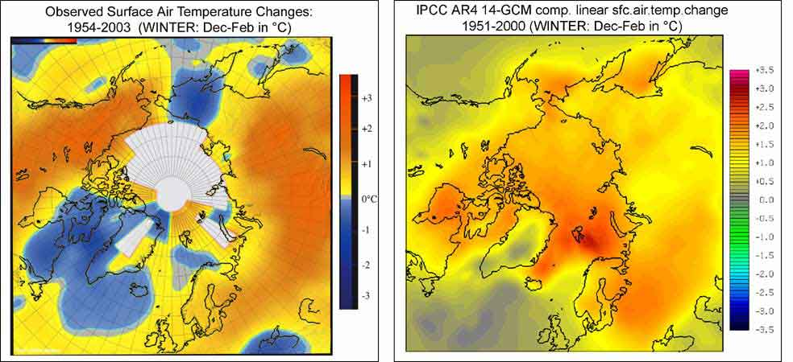

Figure 19: Comparison of the observed distribution of temperature changes (ACIA, 2004) and the simulation (hindcasting) by the IPCC arctic group (Chapman 2005).

Our first reaction to this surprising result was that GCMs are still not advanced enough for hindcasting. However, this possibility is inconceivable, because the increase of CO₂ measured in the past is correctly used in the hindcasting, and everything we know is included in the computation. The IPCC arctic group’s result is the best result based on our present knowledge. If the greenhouse effect caused the warming, it should be reproducible to some extent by these models, even if the reproduction is not perfect.

It took a few weeks or so before we began to realize another possible implication of this discrepancy: If 14 GCMs cannot reproduce prominent warming in the continental Arctic, perhaps much of this warming is not caused by the greenhouse effect at all. That is to say, because it is not caused by the greenhouse effect, the warming of the continental Arctic cannot be reproduced at least qualitatively by the GCMs. How do we examine that possibility?

If the prominent warming in the continental Arctic (Figure 18, upper, and Figure 19, left) is due to the greenhouse effect, the prominent trend should continue after 2000. That is, we should observe an amplification of continental Arctic warming in this century that will be even greater than the amplification that was observed during the last half of the last century, because the amount of CO₂ continues to increase at an exponential rate. Thus, we examined the warming trend during just the last 20 years or so, provided by Hansen (2006). To our surprise, the prominent continental Arctic warming almost disappeared in those results; the Arctic warmed at a rate about like that of the rest of the world, while Greenland showed a strong warming (the lower part of Figure 18), instead of cooling during the last half of the last century. Actually, in Fairbanks, Alaska, the temperature shows a cooling trend between 1977 and 2001, as can be seen in Figure 20 (Hartman and Wendler, 2005). The sudden increase of temperature in 1975 is another indication that this particular warming is not likely to be due to the greenhouse effect of CO₂. It is likely that such a change is caused by shifts of the atmospheric pressure patterns due to unknown causes. In fact, the cause of the Little Ice Age may be partially related to such a shift. Therefore, our conclusion at the present time is that much of the prominent continental Arctic warming and cooling in Greenland during the last half of the last century is due to natural changes, perhaps to multi-decadal oscillations like the Arctic Oscillation, the Pacific Decadal Oscillation, and the El Niño. This trend is shown schematically in Figure 1b as positive and negative fluctuations. If this is indeed the case, the IPCC Report is incorrect again in stating that the warming after 1975 is particularly caused by the greenhouse effect.

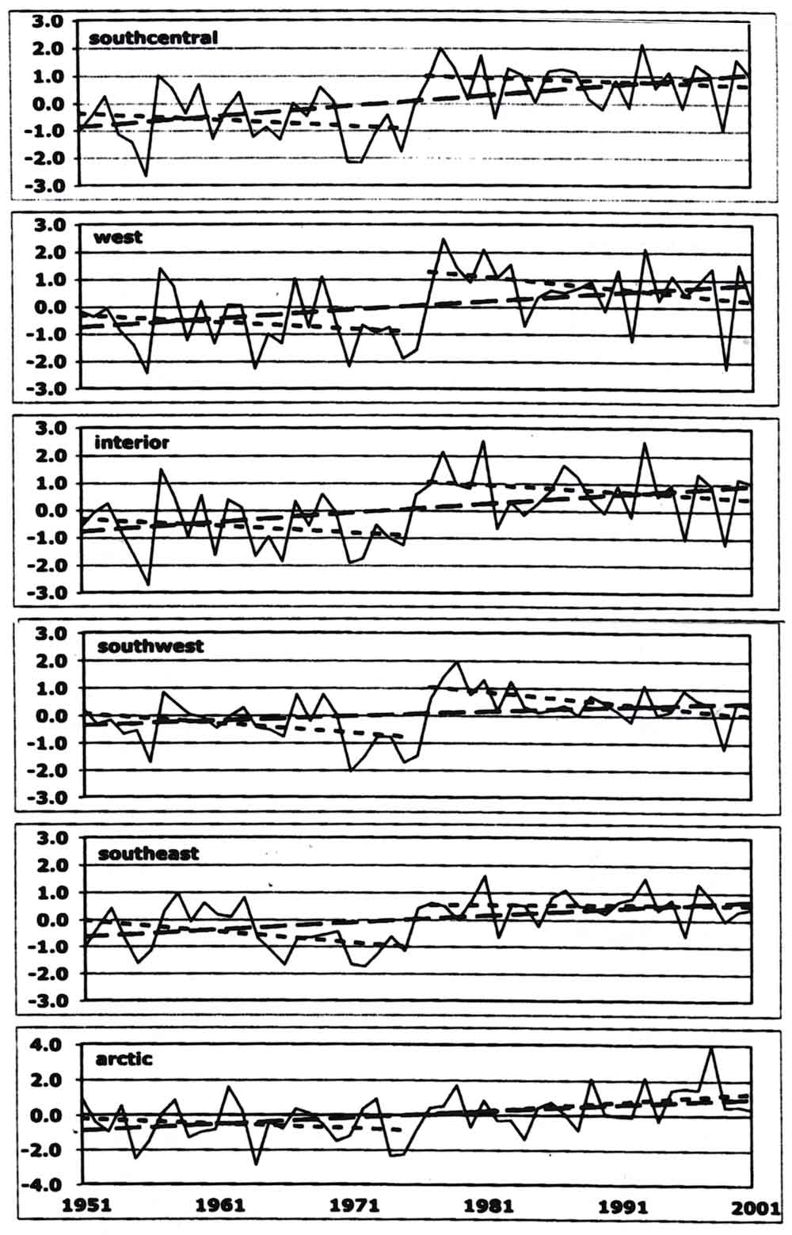

Figure 20: The transition from the period of declining temperature (1940-1975) to the period of rising temperature after 1975. The transition is a step-function-like change, unlike the Greenland effect. Further, after a step-function-like increase, the trend appears to be negative (B. Hartmann and G. Wendler, 2005).

In this connection, it might be added that permafrost temperatures have stopped rising during the last several years (Richter-Menge et al., 2006); see Figure 21. The amount of methane (CH₄) has ceased to increase since about 2000. It is puzzling why permafrost temperatures do not show an accelerated increase after 2000, if the increase from 1986 to 2000 was due to the greenhouse effect; the increase may be temporal fluctuations.

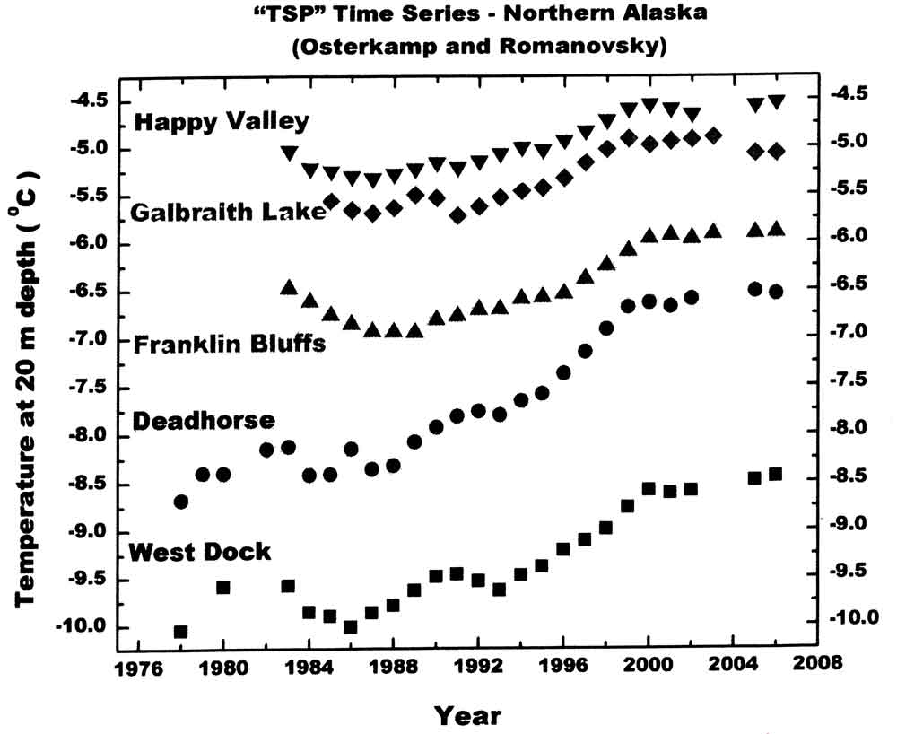
Figure 21: Permafrost temperature variations in Northern Alaska from 1976 to 2006. Note that the temperature increase starting in about 1988 stopped in about 2000 (Richter-Menge et al., 2006).

We have another example to show that GCM results can be used to examine warming processes other than the greenhouse effect of CO₂. Figure 22 shows results of various models on the shrinking sea ice in the Arctic Ocean, together with data from satellite observations. Both model results and satellite data show a shrinking trend. However, the satellite data show a much steeper decline than all the model results. Since the models take into account the observed amount of CO₂ during the observation period, some processes must have been occurring that are not considered at this time or not properly taken into account in GCMs. It may well be that the inflow of warm North Atlantic water is one such process. It is well known that winds or ocean currents can move massive sea ice.

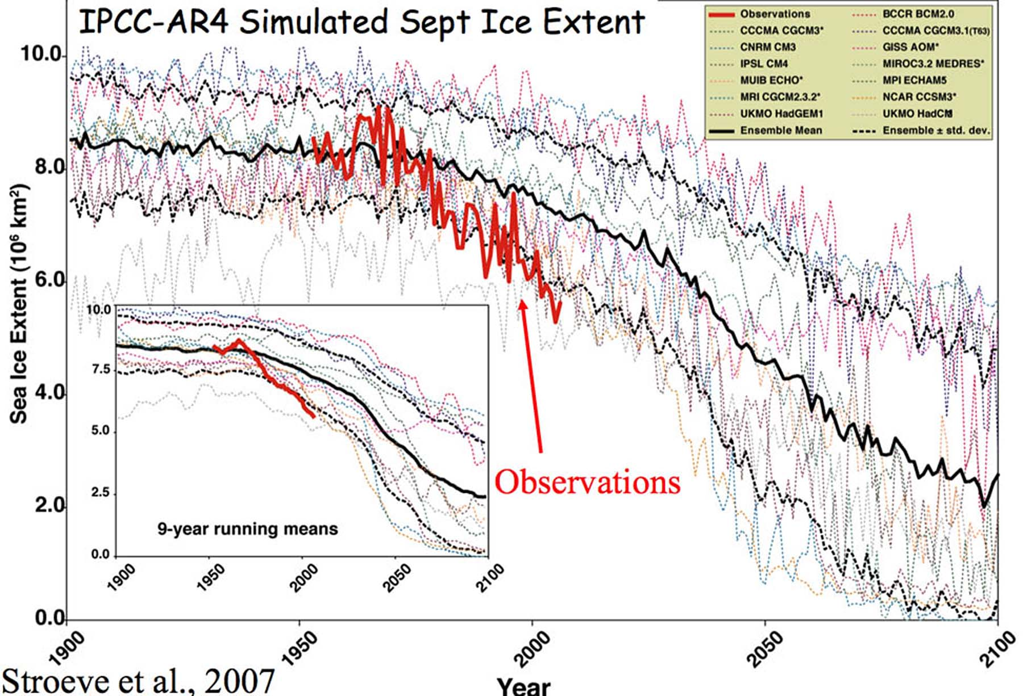

Figure 22: Changes in the area of Arctic Ocean sea ice; comparison of computer modeling results with observations.

4. Summary

From the data provided in the earlier sections, it is quite obvious that:

(1) The temperature change during the last 100 years or so, both the linear change and fluctuations, includes significant natural changes.
(2) The Earth is in the process of recovering from the Little Ice Age.
(3) The present warming is not unusual or abnormal. It is very puzzling that the IPCC Reports simply state that it is mostly due to the manmade greenhouse effect.

Further, unfortunately, computers are already incorrectly “taught,” “instructed,” or “tuned” that the 0.6°C - 0.7°C/100 years rise during the last hundred years is caused by the greenhouse effect, so that their results cannot be used as proof of the greenhouse effect. Therefore, the predicted temperature in 2100 is not correct, because it is based on incorrect instruction.

Regardless of the cause of the Little Ice Age, it is urgent that natural temperature changes be correctly identified and accurately removed from the present on-going changes in order to find the contribution of the greenhouse effect. Only then will an accurate prediction of future temperature changes become possible.

One lesson here is that it is not possible to study climate change without long-term data. In fact, one way to learn about natural changes is to examine climate change before the greenhouse effect of CO₂ became significant. It is very easy to discredit the results of the traditional paleoclimate change studies in terms of accuracy. A study of climate change has some aspect of anthropology or archaeology. However, this is what climatologists must face because there was no thermometer data before the 17th Century. Nevertheless, as mentioned earlier, one certain way to learn about natural changes is to examine climate change before the greenhouse effect of CO₂ became significant. In some sense, inaccurate data (compared with modern data) available for the last few hundred years are more important than accurate satellite data after 1970 in our study of global warming. Unfortunately, at this time, many studies are focused only on climate change after 1975, because satellite data have become so readily available. A study of climate change based on satellite data is a sort of “instant” climatology. Based on satellite data, it is often reported that climate change is “unprecedented.” For example, although there are a number of reports on the condition of ice in Greenland these days, Chylek et al. (2006) reported that present changes of the Greenland ice sheet are smaller than changes observed during the 1920-1940 period.

Conclusion

I would like to emphasize:

(i) Natural components are important and significant, so they should not be ignored.
(ii) Two natural changes are identified in this note: a linear increase of about +0.5°C/100 years and fluctuations superposed on the linear change.
(iii) It is likely that the Earth is still recovering from the Little Ice Age.
(iv) There is nothing unusual or abnormal about the present global warming trend and temperature.
(v) It is insufficient to study climate change on the basis of data from only the last 100 years.
(vi) It is difficult to reach a conclusion about causes of the temperature rise after 1975 until we can understand the rise from 1920 to 1940.
(vii) Because of these deficiencies of the present global warming studies, the GCMs cannot prove that the warming (0.6°C - 0.7°C/100 years) is caused by the greenhouse effect; and thus,
(viii) Future prediction of warming by GCMs is uncertain, because computers are taught that the present warming is caused mostly by the CO₂ greenhouse effect.
(ix) Nevertheless, we presented two examples in which GCM results can be used to identify natural changes of unknown causes.

If most of the present rise is caused by the recovery from the Little Ice Age (a natural component) and if the recovery rate does not change during the next 100 years, the rise expected from the year 2000 to 2100 would be 0.5°C. This rough estimate is based on the recovery rate of 0.5°C/100 years during the last few hundred years. The contribution of the greenhouse effect is much less than what is predicted by GCMs and the IPCC. Multi-decadal changes could be either positive or negative in 2100. In that case, to insist, “Stop global warming” is like stating, “Stop the Earth’s rotation.”

References:

ACIA (Arctic Climate Impact Assessment), Cambridge University Press, 2005.
Alaska Geographic, Glaciers of Alaska, vol. 28, No. 2, 1993.
Alley, R.B., The Younger Dryas cold interval as viewed from central Greenland, Quaternary Science Reviews, 19, 213-226, 2000.
Burroughs, W.J., Climate Change, Cambridge Univ. Press, 2001.
Chapman, W., private communication, 2005.
Chylek, P., N.K. Dubey, and G. Lesins, Greenland warming of 1920-1930 and 1995-2005, Geophys. Res. Lett., 33, L11707, 2006.
Crowley, T.J. and G.R. North, Paleoclimatology, Oxford Univ. Press, 1991.
Fagan, B., The Little Ice Age, Perseus Book Group, 2000.
Fritzsche, D., R. Schutte, H. Meyer, H. Miller, F. Wilhelms, T. Opel, and L.M. Savatyugin, Late Holocene ice core record from Akasemii Nauk Ice Cap, Severnaya Zemlya, In: Dowdeswell, J.W., and I.C. Willis, eds., Annals of Glaciology, No. 42, A150, 2006.
Gribbin, J. (ed.), Climate Change, Cambridge Univ. Press, 1978.
Grove, J.M., Little Ice Age, In: Encyclopedia of the Arctic (p. 477), Routledge, 2005.
Grove, J.M., The Little Ice Ages, Methuen, 1988.
Hansen, J., Private communication, 2006.
Hansen, J., L. Nazarenko, R. Ruedy, M. Sato, J. Willis, A. Del Genio, D. Koch, A. Lacis, K. Lo, S. Menon, T. Novakov, J. Perlwitz, G. Russell, G. A. Schmidt, and N. Tausnev, Earth’s energy imbalance: Confirmation and implications, Science, 308, No. 5727, 1431-1435, 2005.
Hartmann, B. and G. Wendler, The significance of the 1976 Pacific climate shift in the climatology of Alaska, J. Climate, 18, 4824, 2005.
Holgate, S.J., On the decadal rates of sea level change during the twentieth century, Geophys. Res. Lett., 34, L01602, 2007.
IPCC (Intergovernmental Panel on Climate Change), http://www.ipcc.ch.
Jones, P.D., Hemisphere surface air temperature variations: A reanalysis and an update to 1993, J. Climate, 1, 1794, 1994.
Jones, P.D., Hemispheric surface air temperature variations: Recent trends and update to 1987, J. Climate, 1, 654, 1988.
Jones, P.D. and R.S. Bradley, Climatic variations in the longest instrumental records, In: Climate Since A.D.1500 Bradley, R.S. and P.D. Jones, Eds., pp. 246-268, Routledge, London, 1992.
Keigwin, L.D., The Little Ice Age and medieval warming period in the Sargasso Sea, Science, 274, 1504, 1996.
Lamb, H.H., Climate, History, and the Modern World, Methuen, 1982.
Polyakov, I., private communication, 2006.
Polyakov, I.V., G. V. Alekseev, R.V. Bekryaev, U. Bhatt, R.L. Colony, M.A. Johnson, V.P. Karklin, A.P. Makshtas, D. Walsh, and A.V. Yulin, Observationally based assessment of polar amplification of global warming, Geophys. Res. Lett., 29, No. 18, 1878, 2002.
Polyakov, I., et al., Observational program tracks Arctic Ocean transition to a warmer state, EOS, 88, 398, 2007.
Richter-Menge, J., J. Overland, A. Proshutinsky, V. Romanovsky, J.C. Gascard, M. Karcher, J. Maslanik, D. Perovich, A. Shiklomanov, and D. Walker, Arctic Report, pp. S46-S52, In: K.A. Shein (ed.), State of the Climate in 2005, NOAA/NESDIS/NCDC and American Meteorological Society Report, BAMS, 2006.
Robinson, A.B., N.E. Robison, and W. Soon, Environmental effects of increased atmospheric carbon dioxide, J. American Physician and Surgeon, 12, 79, 2007.
Romanovsky, V., private communication, 2006.
Scafetta, N. and B.J. West, Phenomenological solar signature in 400 years of reconstructed Northern Hemisphere temperature record, Geophys. Res. Lett., 33, L1778, 2006.
Serreze, M. and J.A. Francis, The arctic amplification debate, Climate Change, 76, 241, 2006.
Serreze, M.C. and R.G. Barry, The Arctic Climate System, Cambridge Univ. Press, 2005.
Soon, W.W.-H., Variable solar irradiance as a plausible agent for multidecadal variations in the Arctic-wide surface air temperature record of the past 130 years, Geophys. Res. Lett., 32, L16712, doi:10.1029/2005GL023429, 2005.
Tarand, A. and P.O. Nordli, The Tallinn temperature series reconstructed back half a millennium by use of proxy data, Climate Change, 48, 189, 2001.
Thompson, L.G., Ice core evidence from Peru and China, In: Climate since A.D. 2500, Bradley, R.S. and P.D. Hones (eds.), Routledge, 1992.
van Engelen, A.F.V., J. Buisman, and F. Ijnsen, History and Climate - Memories of the Future, A millennium of weather, winds, and water in the lower countries, Kluwer Academic Press, New York, Boston, London, 2001.
Vinje, T., Anomalies and trends of sea-ice extent and atmospheric circulation in the Nordic seas during the period 1864-1998, J. Climate, 14, 255-267, 2001.
Wilson, R.C.L., S.A. Drury, and J.L. Chapman, The Great Ice Age, Routledge, 2000.

For Further Reading:

Cruikshank, J., Do Glaciers Listen?, University of Washington Press, 2005.
Fagan, B., The Little Ice Age: How climate made history, 1300-1850, Persus Books Group, 2000.
Jones, P.D., A.E.J. Ogilvie, T.D. Davies, and K.R. Britta, History and Climate: Memories of the Future?, Kluwer Academic/Plenum Pub., 2001.
Jones, P.D., Early European instrumental records, History and Climate; Memories of the Future?, Kluwer Academic Plenum Pub., pg. 55, 2001.
Ogilvie, A.E. and T. Jònsson, The Iceberg in the Mist: Northern Research in Pursuit of a “Little Ice Age, Kluwer Academic, 2001.

